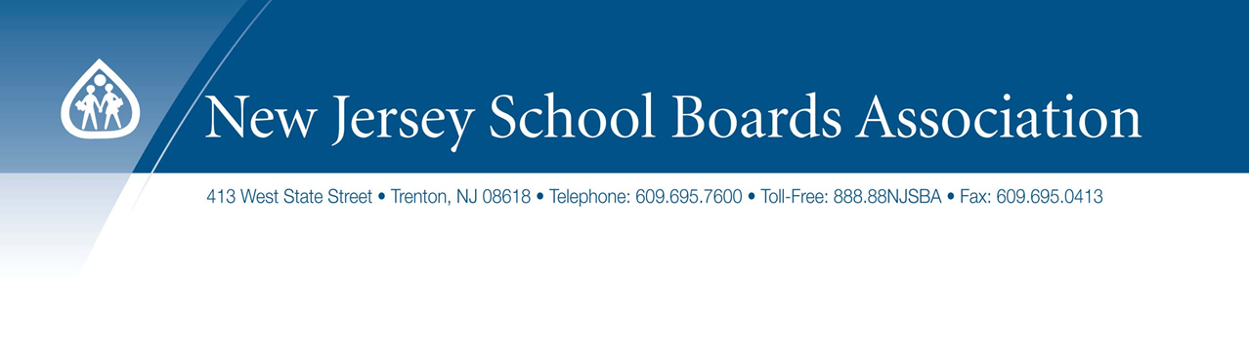
FREDON TOWNSHIP BOARD OF EDUCATION
Fredon Township School
Newton, N.J.
February 13, 2017

Anti-Bullying Bill of Rights Act
Where Are We Now?
The Role of the Board

Michael F. Kaelber, Esq., Director
Legal and Labor Relations Services Department, NJSBA

Definition of Harassment, Intimidation or Bullying (HIB)
N.J.S.A. 18A:37-14

Harassment, intimidation or bullying means any gesture, any written, verbal or physical act, or any electronic communication, whether it be a single incident or a series of incidents, that:
- is reasonably perceived as being motivated either by an actual or perceived characteristic, such as race, color, religion, ancestry, national origin, gender, sexual orientation, gender identity and expression, or a mental, physical or sensory disability, or by any other distinguishing characteristic, that
- takes place on school property, at any school-sponsored function, on a school bus, or off school grounds as provided for in section 16 of P.L. 2010, c.122 (C.18A:37-15.3), that
- substantially disrupts or interferes with the orderly operation of the school or the rights of other students and that:
- a reasonable person should know, under the circumstances, will have the effect of physically or emotionally harming a student or damaging the student’s property, or placing a student in reasonable fear of physical or emotional harm to his person or damage to his property; or
b. has the effect of insulting or demeaning any student or group of students; or
c. creates a hostile educational environment for the student by interfering with a student’s education or by severely or pervasively causing physical or emotional harm to the student.

